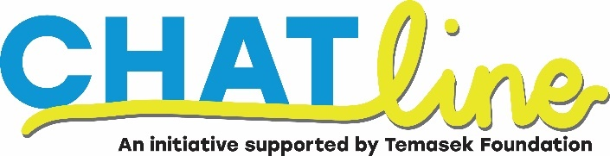

CHATline Peer Supporter Application Form
I am disclosing my personal data and contact information so that I can be contacted for volunteer activities by CHAT. I am aware that CHAT is under the Institute of Mental Health (IMH). In compliance with the Personal Data Protection Act 2012 (PDPA), I hereby give consent to CHAT staff to collect my personal data (below) for the purposes of contacting me for volunteer activities. All information provided in this form will be kept strictly confidential. Please send your queries and concerns to chatline@mentalhealth.sg.
- Personal information
Name:
Birth Year:
Contact Number:
Email:
Gender:
Occupation:
If you are schooling, please state your current school level and the year you are currently in: | Example: Polytechnic Year 2.

- Tell us more about yourself
Language Proficiency:
Have you completed any peer helping workshops before?
If yes, state the organisation that provided the workshop.
Have you been a peer supporter in your school and/or any organisation before (past or present)?
Are you volunteering in other organisations? If yes, what are they and what is your involvement?
Have you been touched (literally/ figuratively) by mental illness before? Please tell us more.
Any medical conditions that you would like us to take note of?
If yes, please specify.

- Declaration

I confirm that the information provided on this application is true. I also agree to abide by all Hospital policies and procedures as set by IMH and/or CHAT.

Full Name. of *Applicant / Parent / Guardian  *delete accordingly  For volunteers under 21 years old | Signature of  *Applicant / Parent / Guardian  * delete accordingly | Date

Send your completed forms to chatline@mentalhealth.sg with the subject title “Volunteer Application – (Your Name)”. Application ends on 31st May 2022.

